|  |  |
| --- | --- |
| Document Name: | **Excalibur Launcher- SRS** |
|  | **S**oftware **R**equirements **S**pecification |
| Document File Path in StarTeam: | D:\ExcaliburLauncher\documentation |
| Revision: | **B** |

Revision History Control

|  |  |  |  |  |
| --- | --- | --- | --- | --- |
| Rev. | Description (changes, additions) | Author | Approved by | Issue Date |
| A | Initial version | Shia |  | 18/2/17 |
| **B** | Updated version | Shia |  | 14/3/18 |
|  |  |  |  |  |
|  |  |  |  |  |
|  |  |  |  |  |
|  |  |  |  |  |
|  |  |  |  |  |
|  |  |  |  |  |

**Table of Contents**

1. Introduction 3

1.1 Scope 3

1.2 Acronyms and Definitions 3

1.3 References 3

2. Overall Description 4

2.1 Product Perspective 4

2.2 Product Architecture 5

2.3 Software Functions 5

3. Functional Requirements 6

3.1 Display Excalibur Devices 7

3.2 Display Modules 8

3.3 Utility Programs 9

3.4 Setup Device Configuration 10

3.5 Save to Registry 11

4. Interface Requirements 12

4.1.1 User Interface and GUI 12

4.1.2 Launcher Main Screen 12

4.1.3 Excalibur Devices 12

4.1.4 Excalibur Modules 13

4.1.5 Utility Programs 13

4.2 Hardware Interfaces 13

4.3 Software Interfaces 13

5. Risks 14

5.1 Access to Excalibur software tools written in C and C++ 14

5.2 WPF Platform 14

6. T.B.D Follow-up 15

7. T.B.D Follow-up 16

# Introduction

## Scope

The ***Excalibur Launcher*** shell will provide a single source for running and monitoring the status of installed Excalibur devices and software.

***Excalibur Launcher*** The Excalibur hardware and the software tools available for these products.

## Acronyms and Definitions

|  |  |
| --- | --- |
| EL | Excalibur Launcher |
|  |  |

## References

|  |  |  |
| --- | --- | --- |
|  | Document Title | Revision |
|  |  |  |

# Overall Description

## Product Perspective



## Product Architecture



## Software Functions

Detect any Excalibur devices on PC by reading the registry

Check found devices or installed and working

Display devices found and status

# Functional Requirements

**Excalibur Launcher Use Case Diagram**

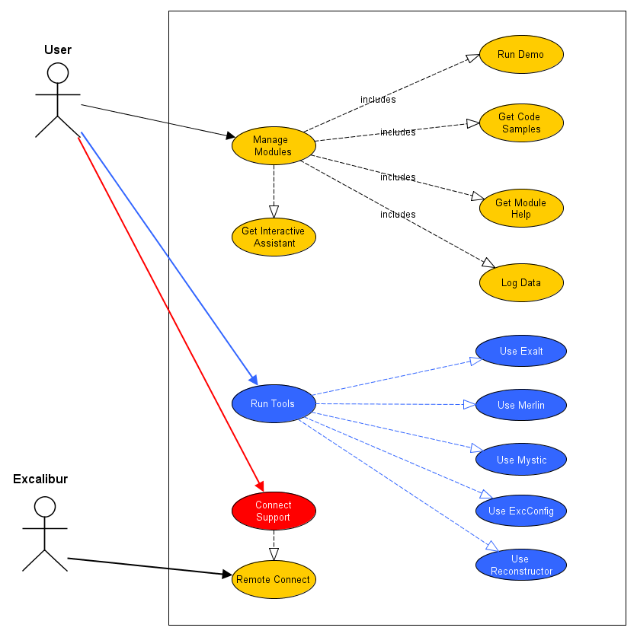

## Display Excalibur Devices

* **Goal**

Search PC to find Excalibur devices and modules and display in Launcher

* **Description**

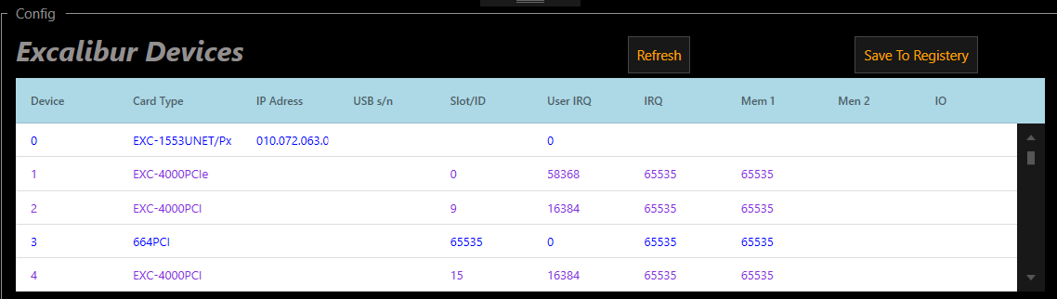

**On running**

On execution ***Excalibur Launcher*** will search the PC for installed

Excalibur devices and also read the registry.

All the devices found will be displayed in a grid, with a different color indicating whether the device actually exists in the PC or is only defined in the registry.

Devices found in the registry will display other information like IP Address and slot ID.

* **Actors**

User, PC with installed Excalibur devices and ***Excalibur Launcher*** software

* **Pre-conditions**

***Excalibur Launcher*** started

* **Post-conditions**

***Excalibur Launcher*** displays devices including name and status

* **Processing**

**Basic Flow**

1. *The case begins when the User starts* ***Excalibur Launcher***
2. Onstartup ***Excalibur Launcher*** *searches for installed Excalibur devices* and devices written to the registry.
3. Launcher then combines the list of devices found in the PC and those written to the registry.
4. *Use case ends when*Launcher displayed the combined list with details of IP Address and Slot-ID.

## Display Modules

* **Goal**

When user selects one of the devices displayed in the grid, if the card contains modules they are shown in the Modules section of the screen. Including module type, firmware and hardware.

* **Description**

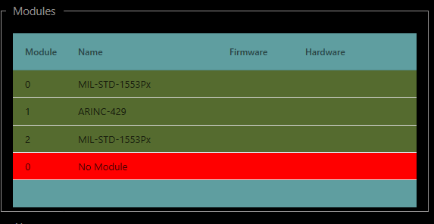

When a user selects one of the displayed devices and the device has modules on the card then the modules will be displayed in the modules section. Green indicating a working initialized module, yellow a module which did not initialize and red for no module.

* **Actors**

User, ***Launcher***, device with modules

* **Pre-conditions`**

Launcher running with device selected

* **Post-conditions**

***Launcher*** displays modules

* **Processing**

**Basic Flow**

1. The case begins when the User selects a device in the grid
2. The ***Launcher*** will verify if module found and initialized***.***
3. ***Launcher*** displayed modules

## Utility Programs

* **Goal**

Utility software will be available to the user by pressing one of the buttons displayed below.

* **Description**

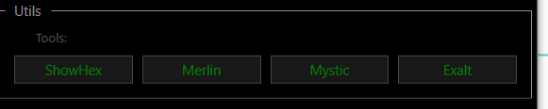

When selecting one of the options **(*ShowHex*, *Merlin*, *Mystic* or *Exalt*)** the launcher will run the selected program or go to the appropriate link on the Excalibur web site in to download the software

* **Actors**

User, PC with installed Excalibur devices and ***Excalibur Launcher*** software

* **Pre-conditions**

***Excalibur Launcher*** started

* **Post-conditions**

***Excalibur Launcher*** runs one of the selected programs

* **Processing**

**Basic Flow**

1. The case begins when the *User* presses one of the Utilities programs
2. Launcher runs the Program.
3. If not found, then launcher opens link on Excalibur web site

## Setup Device Configuration

* **Goal**

Define device and parameters needed to setup card and to save to registry

* **Description**

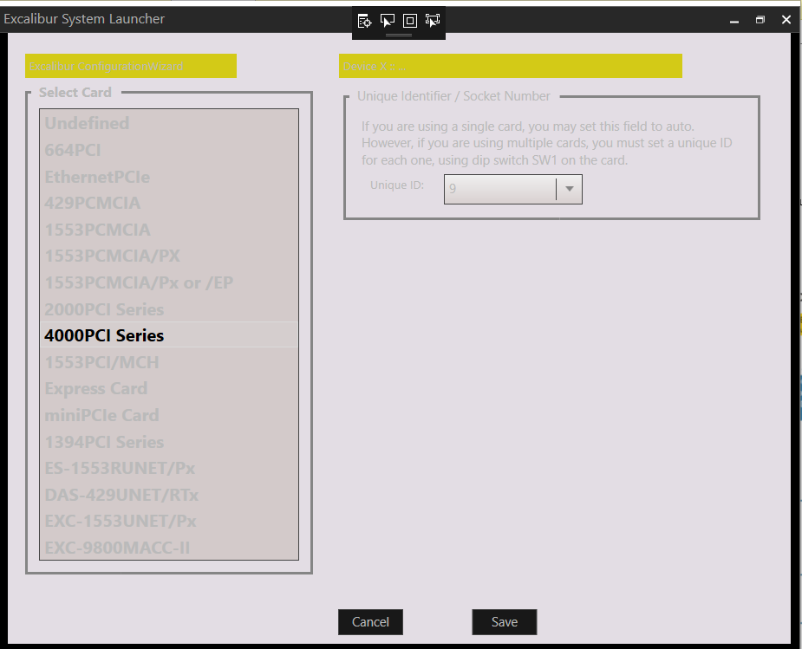

* **Actors**

User, PC with installed Excalibur devices and ***Excalibur Launcher*** software

* **Pre-conditions**

***Launcher*** running

* **Post-conditions**

***Launcher*** saves device parameters

* **Processing**

**Basic Flow**

1. *User* selects device from main screen
2. ***User*** double clicks to open configuration screen
3. ***Launcher*** opens ***Configuration*** screen
4. ***User*** selects device and matching parameters
5. ***User*** selects ***save button*** to*save configuration*
6. ***Launcher*** saves to internal structure
7. *Or cancel to return to main screen without saving*

## Save to Registry

* **Goal**

Save devices parameters to the registry

* **Description**
* **Actors**

User, PC with installed Excalibur devices and ***Excalibur Launcher*** software

* **Pre-conditions**

***Excalibur Launcher*** running

* **Post-conditions**

Device parameters saved to the registry

* **Processing**

**Basic Flow**

1. *The case begins when the User selects* ***Save to Registry***
2. *Launcher saves device parameter to the registry*

# Interface Requirements

### User Interface and GUI

### Launcher Main Screen

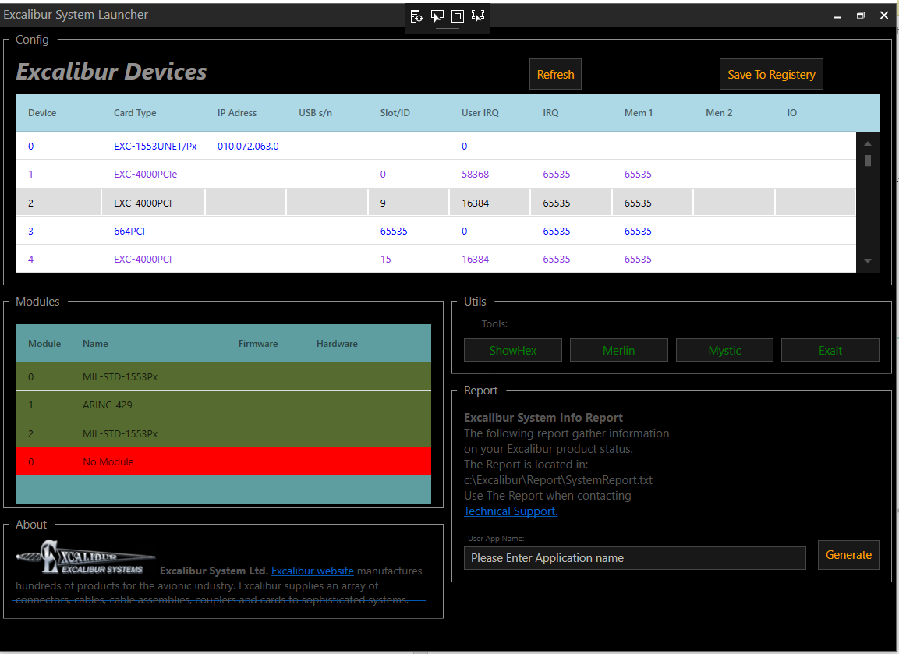

### Excalibur Devices



### Excalibur Modules



### Utility Programs



## Hardware Interfaces

Use Software tools and drivers to establish connection between installed devices/modules and ***Excalibur Launcher.***

## Software Interfaces

Call Excalibur 4000 card dll to obtain information about installed devices and modules.

# Risks

## Access to Excalibur software tools written in C and C++

**Description:**

Excalibur software tools are written in C+ and C, the **EL** is written in C#. We need a software development tool that connects programs written in C and C++.

**Probability:1`**

**Severity:** 2

**Mitigation:**

SWIG has none been included with C# code and seems to be working using the software functions uses for far

## WPF Platform

**Description:**

In order to expand our knowledge base and learn new tools the launcher project will be written using c# and wpf.. wpf is a completely new development environment not similar to MFC requirering time allocated for learning the new concepts and developing the project.

**Probability:3`**

**Severity:** 3

**Mitigation:**

1. Course in WPF
2. Buy books

# T.B.D Follow-up

|  |  |  |
| --- | --- | --- |
| **TBD** | **Responsibility** | **Due Date** |
| Launcher was developed to be compatible with ExcConfig. But is capable of detecting a greater range of cards. but for now, disabled to keep compatible with ExcConfig | Shia | SW Manager to decide when appropriate |
|  |  |  |
|  |  |  |

# T.B.D Follow-up

Review back the entire document from the beginning. If there are any TBDs add them to the following TBD follow-up table, and specify who is responsible to resolve the TBD and when.

|  |  |  |
| --- | --- | --- |
| **TBD** | **Responsibility** | **Due Date** |
| The name of the section with a TBD and the issue that is TBD | Who is responsible to resolve the TBD | The Date, or a phase or stage in the development life cycle, when the TBD will be resolved |
|  |  |  |
|  |  |  |